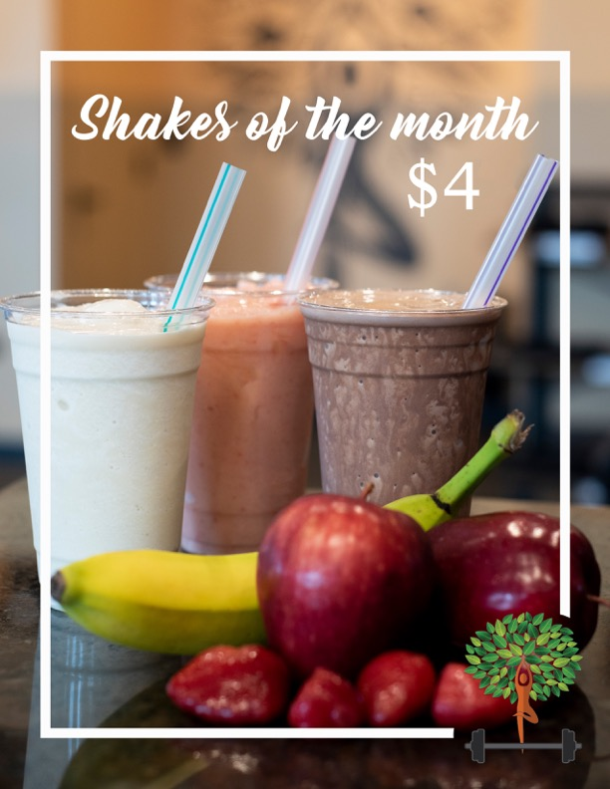
- Cookie Monster
- Coconut Almond
- Butter Pecan
-Strawana
November 2026

